Google Drive (Step 1)
Introduction: For the research project, you can either use the old-fashioned Bibliography Cards and Note Cards or try something new with use: Google Docs! Here are some instructions for using these sources.

Google Drive Instructions:
If you already have a Google/YouTube/GoogleDrive/Google+Account, you can skip this step
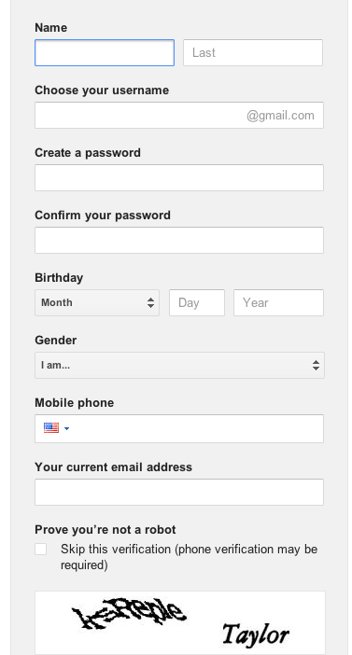
1. Visit www.Google.com

2. In the top right corner, click “Sign In”

3. On the following page, click “Sign Up”

4. You will see a menu that looks like this

5. Enter your name, and then create a user name and password. Follow this Pattern:

BW+LastName+FirstIntial Add a number if needed

Ie. John Smith would be

BWSmithJ@gmail.com

Include other information (age, phone number, other email address) only if you want. This is optional.

6. Click “Next Step” twice, and then click “Get Started”

7. You will now be on the Google Home Page. Congratulations!! You’re ready for step 2.

Go to EasyBib.com and flip this page over….

EasyBib.com (Step 2)
EasyBib Instructions

1. Go to www.easybib.com

2. In the top right corner, click “Login”

3. Select “Sign In” with Google Account 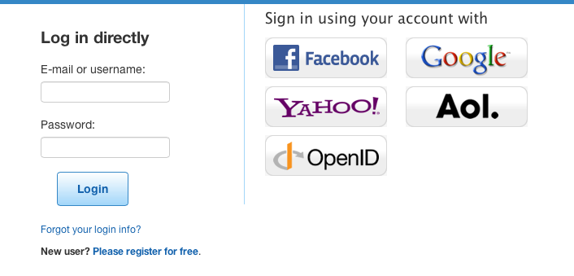
4. Congratulations, you’ve set up an EasyBib.com Account!!

About EasyBib:

EasyBib is free site, which will greatly help your creation of Bibliography Cards and citations. Even though it’s up to you to double-check everything, this will save you a lot of time.

Once you have logged in, created a new “project”. Title it something like “CP 10 or CP 12 Research Project” or something else you’ll remember. You will want to use this again in high school.

Once you have done this, you can use the tool to enter your sources. Notice the tabs at the top for all of the different types of sources.

EasyBib will automatically save your information so you can always access it later.

How to Make a Digital Bibliography
1. Go to mrharrold.com/research-project-10
(or mrharrold.com/research-project-12)
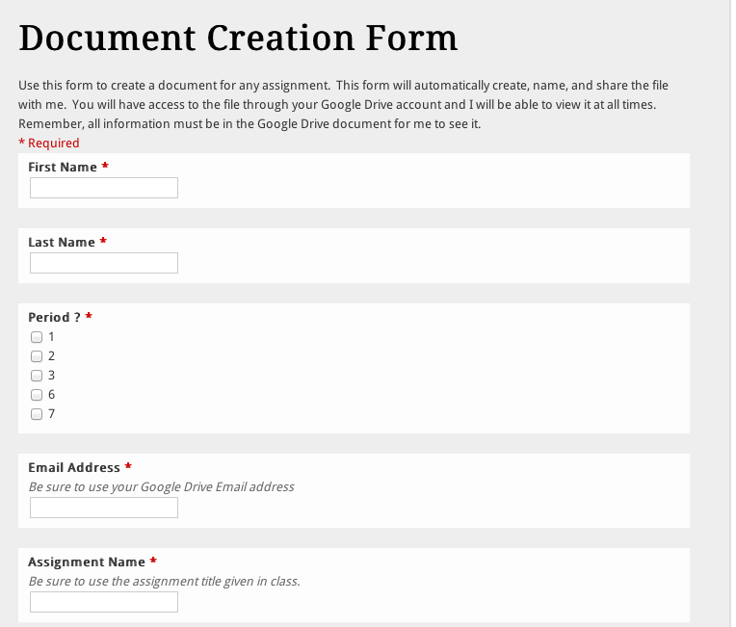
2. Scroll down to this Google Form:

3. This will automatically create an appropriately title Google Doc which is shared with my account and your account. You will receive an email sent to your new Gmail and a copy will appear in your Google Docs.

4. Open the new Google Doc and begin typing your Bibliography.

But what about EasyBib?

While you can feel free to type directly into the Google Docs Form to write your Bibliography, EasyBib will also work.

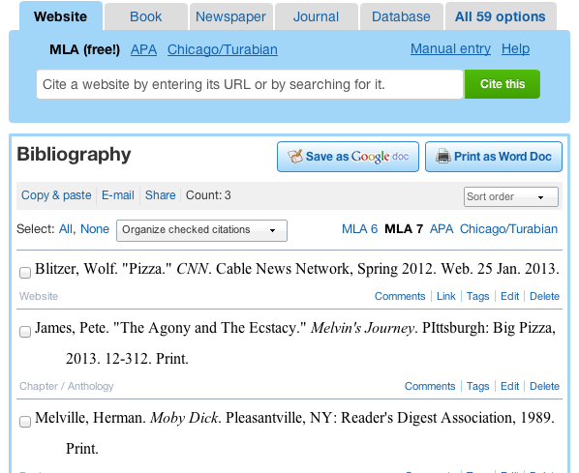
1. Create your bibliography in Easy Bib.

2. When you’re finished, click “copy & paste”

3. Copy and Paste the Bibliography into Google Docs. Make sure it’s double-spaced.

4. You’re done!

How to Take Digital Notes
Introduction: There are thousands of ways to take notes. In the past, you’ve used notecards, but you can also use a notebook, a Microsoft Word document, or any other combination of tools. If you want to take digital notes, follow these simple steps:

1. Go to mrharrold.com/research-project-10
(or mrharrold.com/research-project-12)

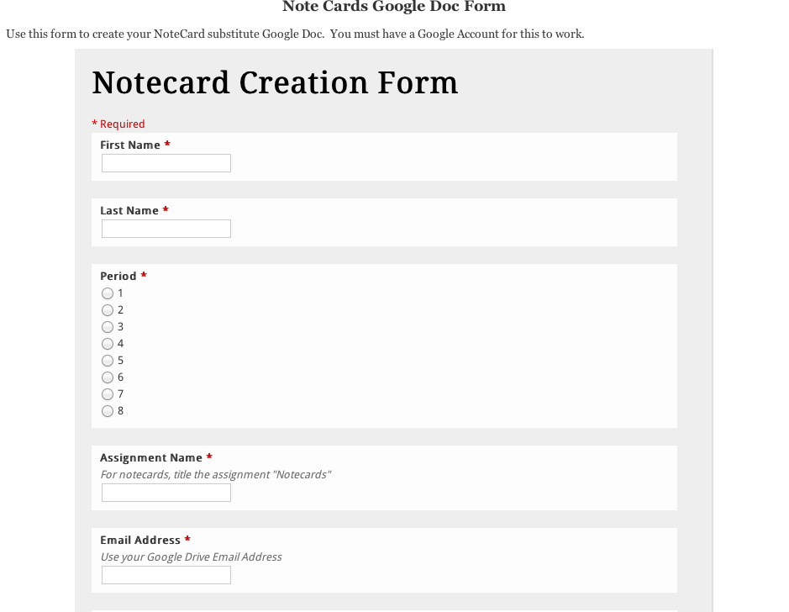
2. Scroll down until you find this form.

3. Fill out the form, and Google will automatically create a Google Doc that’s titled properly and shared with me.

4. Open the new form, and take a look at the chart.

5. Use the chart to take your notes. Remember to record the source name, the type of note (Q/P/S), the topic of the note, and the page number.

6. Be sure to complete at least 50 notes, but feel to take as many as possible.

7. When you’re finished, you’re done!
