Julius Caesar Act I

Background: Did You Know?
In Act I, Julius Caesar attends the feast of Lupercal, held yearly to honor a fertility god. It began with a sacrifice of goats and a dog at the Lupercal, a cave where Rome’s legendary founders, Romulus and Remus, allegedly were nursed by a she-wolf. Young men called “Luperci” would dress themselves in the goatskins and run around the Palatine Hill, one of the seven hills on which ancient Rome was built. They carried goat thongs that they used to strike people, especially women who could not have children. The ritual was said to help women become fertile. The Romans celebrated dozens of religious festivals, many involving games or spectacles. These events provided amusement for the people and gave leaders an opportunity to interact with common people.

In Shakespeare’s plays, characters sometimes make speeches when they are along on stage. These soliloquies reveal a character’s private thoughts and are a means of providing important information to the audience. In Act I, Scene ii, Cassius delivers a soliloquy that reveals a plot to influence Brutus to participate in the conspiracy to overthrow Caesar. It involves sending letters to Brutus that express the Romans’ high regard for him. Related to soliloquies are asides – comments made to the audience that cannot be heard by the other characters present on stage.
Key Terms
- Anachronism- an event or detail that is inappropriate for the time period

- Pun- a play on the multiple meanings of a word or on two words that sound alike but have different meanings

Act I, Scene I
Scene 1:

1. What is the setting? What holiday is being celebrated?

2. Who are Marullus and Flavius?

3. Why do they want to drive the commoners from the street?

4. What else do Marullus and Flavius do to further hinder the celebration of Caesar’s victory?

Scene 2:

5. What does Caesar tell Antony to do to Calpurnia?

6. Why might Caesar ask Antony in front of everyone else?

7. What is a soothsayer? Of what does he warn Caesar?

8. What does ides mean?

9. Does Marcus Brutus like Caesar? What does Brutus think of Caesar’s rise to power? Use lines from play to support your answer.

10. Brutus says, “For let the gods so speed me as I love / The name of honor more than I fear death.” What do these lines imply about Brutus’s most important value in life?

11. What story does Cassius tell Brutus?

12. What is Cassius’s point in telling this story?

13. What is Caesar’s opinion of Cassius? Why does he feel this way?

14. What handicap does Caesar reveal about himself when speaking to Antony?

15. How many times was Caesar offered a coronet, or a small crown?

16. What was Caesar’s reaction to the offering, according to Casca?

17. What sickness does Caesar have?

18. What happens to Marullus and Flavius?

19. What does Cassius plan to do to convince Brutus to conspire against Caesar?

Scene 3:

20. What unusual events occur during the storm?

21. What meaning does Cassius interpret from the storm?

22. According to Casca, what are the senators planning to do to Caesar tomorrow?

23. Who is definitely part of the conspiracy?
1. 4.
2. 5.
3. 6.

Julius Caesar Act II

Background – Did You Know?
Marcus Brutus claimed to have descended from the founder of the Roman Republic. In 509B.C., Lucius Junius Brutus led a revolt against Tarquinius Superbus, Rome’s seventh king. Ancient historians describe Tarquinius as a tyrant who killed many senators. Brutus supposedly expelled him and his family after Tarquinius’s son took advantage of a noblewoman. Brutus, one of the first consuls elected, made the Roman people swear never to accept another king. Much of the story may be legend, but it does reflect the Romans’ long-standing dislike of kings. Even the emperors avoided using the title.

Suspense is the anticipation of the outcome of events, especially as they affect a character for whom one has sympathy. Suspense produces an uncertainty that causes anxiety. For instance,
Act I of Julius Caesar raises the question of whether Brutus will join Cassius’s conspiracy. As you read Act II of Julius Caesar, take note of the incidents that increase the level of suspense.
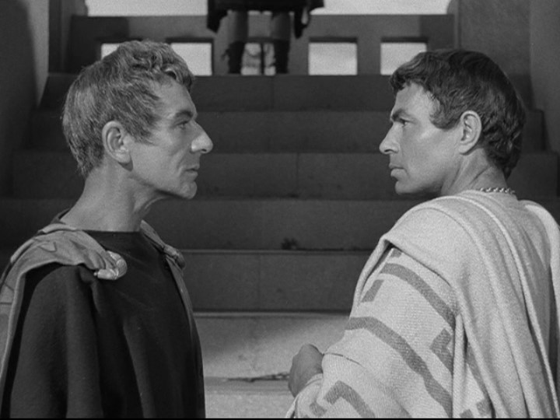

Act II Questions
Scene 1:
1. According to Brutus, why is it is necessary that Caesar be killed?

2. What actions does Lucius perform that help the plot unfold?

3. What is Brutus’s internal conflict?

4. Why does Brutus disagree about taking an oath?

5. Why does Metellus think it would be a good idea to ask Cicero to join the conspiracy?

6. Why does Brutus say they should not ask Cicero to join the conspiracy?

7. What does Brutus say about killing Marc Antony?

8. What reason does Cassius give for why Caesar might not come out of his house today?

9. By what method does Decius say he will use to get Caesar out of the house?

10. Why is Portia, Brutus’s wife, worried about Brutus?

11. How does she prove her strength to Brutus?

Scene 2:
12. Why does Calpurnia want Caesar to stay home?

13. Describe Calpurnia’s dream.

14. How does Decius interpret the interpret Calpurnia’s dream?

15. What arguments does Decius use to change Caesar’s mind about going to the Capitol?

Scene 3:
16. What does Artemidorus plan to do?

Scene 4:

17. Why is Portia so nervous?

18. What does Portia want Lucius to do?

19.What does the soothsayer tell Portia?

Julius Caesar Act III

Background – Did You Know?
Shakespeare based Julius Caesar on an English translation of Parallel Lives by the Greek writer Plutarch. This work contains paired biographies of Greek and Roman historical figures, including Caesar, Brutus, Antony, and Cicero. Plutarch was especially interested in his subjects’ character and motives. In the play, Shakespeare generally followed Plutarch’s portrayal of the historical figures, but he did make subtle changes. For example, Plutarch reveals that Cassius enjoyed making jokes and that Brutus hesitated to join the conspiracy because it would put so many lives in danger. In Shakespeare’s play, Cassius is always serious; Brutus cares only about whether Caesar deserves to die. Antony’s magnificent public speech in Act III is mainly Shakespeare’s creation. In Plutarch’s work, he describes it in a few sentences.

Julius Caesar contains examples of the three types of irony. Dramatic irony occurs when the audience or reader knows something that a character does not know. For example, the reader knows that Cassius sent the letters to Brutus anonymously, but Brutus believes that they are from Roman citizens. Situational irony occurs when what actually happens is the opposite of what is expected or appropriate. For example, Caesar expects to be crowned king at the Senate, but instead he was assassinated. Verbal irony occurs when a writer or speakers says one thing but really means its opposite. For example, Antony says that, compared to Brutus, he is not an orator, but Antony’s speech clearly shows that he is. Verbal irony is especially prominent in Antony’s speech in Act III. Look for more examples.
Key Terms
- Apostrophe- a rhetorical figure in which the speaker addresses a dead or absent person, an abstraction, or inanimate object

- Foil Character- a character who serves as a contrast to another character

- Rhetorical Questions – when a speaker/writer asks questions to the audience without the expectation of direct answers

Scene 1:
1. What reason does Caesar give for not reading Artemidorus’s letter?

2. What Roles do the following characters play in the conspiracy?
Trebonius:

Metellus Cimber:

Casca:

3. What is Caesar’s opinion of himself?

4. What does “Et tu, Brute?” mean? How do these words relate to the theme of friendship in the play?

5. Where does Caesar’s dead body lie? How is this ironic?

6. What does Brutus tell the conspirators to do after killing Caesar?

7. What promise does Brutus tell the servant to relay to Antony?

8. What does Antony say about the possibility of being killed by the conspirators?

9. After being assured he is in no danger, what favor does Antony ask of the conspirators?

10. What does Cassius think about granting Antony this favor?

11. What restrictions does Brutus set?

12. Summarize Antony’s main points in his speech to Caesar’s body?

13. Who is coming to Rome to meet with Antony?

Scene 2:

14. According to Brutus’s speech to the commoners, what reasons does he give for Caesar’s death?

15. What is the mood of the crowd as Brutus finishes his speech?

16. What does Brutus offer at the end of his speech?

17. List three points of Antony’s speech that work to persuade the crowd to turn on the conspirators.

18. What reason does Antony give for why he cannot read Caesar’s will?

19. What has Caesar bequeathed the Romans in his will?

20. How does the crowd react to Antony’s speech?

Scene 3:

21. What happens to Cinna the Poet? Why?

Julius Caesar Act IV and V

Background – Did You Know?
Antony used Caesar’s will as a tool to manipulate the public. Yet the will was a mixed blessing for him. Instead of naming Antony heir, Caesar chose Octavius, his great-nephew. The two men could hardly have been more different: Antony, a gregarious and imposing general, and Octavius, a delicate nineteen-year-old. The senators, led by Cicero, supported Octavius. Cicero did not join in the conspiracy, but he approved of Caesar’s assassination and called for Antony’s death also. Octavius turned out to be a shrewd politician. When the senators later turned against Octavius, he joined Antony and Lepidus. The alliance split control of Rome’s territory in three ways. To pay off the troops, they confiscated the estates of many senators and knights, beginning a reign of terror in which thousands perished. Octavius later became Rome’s first emperor and assumed the name of Augustus.

A tragedy is a drama in which the main character, or tragic hero, suffers a downfall. Traditionally, the hero is a person of high rank. His or her downfall usually results from an error in judgment or a fatal weakness or flaw, such as excessive ambition. Critics have long debated whether Julius Caesar or Brutus is the tragic hero of the play. Although Caesar is the title character, he only appears in a few scenes and is killed in Act III.
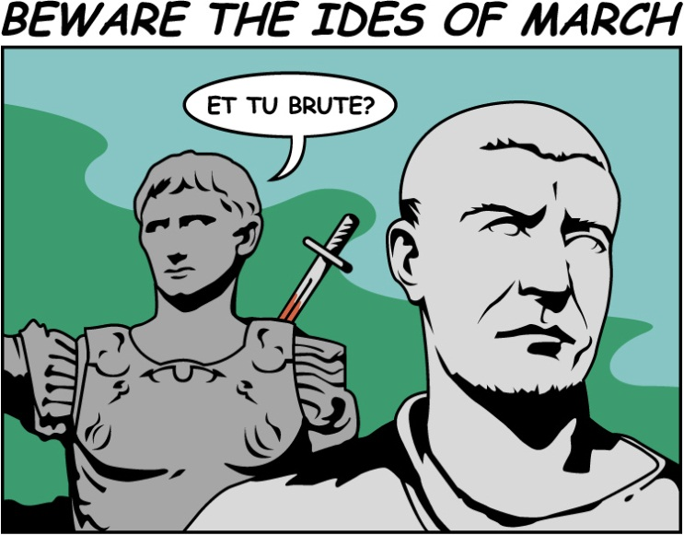

Act IV Questions

Scene 1:
1. Who are the members of the second triumvirate?

2. What kind of list are the three making at the beginning of the scene?

3. What does Antony say they will do to Caesar’s will?

4. What is Antony’s opinion of Lepidus?

5. What reason does Antony give letting Lepidus help in choosing who shall die?

Scene 2:
6. Why does Brutus suggest that he and Cassius talk inside the tent?

Scene 3:
7. Why is Cassius mad at Brutus?

8. What does Brutus accuse Cassius of?

9. For what has Brutus aske Cassius that he did not receive?

10. What does Brutus refuse to do as a means to raise money for his army?

11. How does Portia die?

12. Explain the disagreement that Brutus and Cassius have about the battle strategy?

13. Who wins the argument?

14. What unexpected visitor does Brutus see when everyone else is asleep?

Act V Questions

Scene 1:
1. About what do Octavius and Antony argue?

2. What is significant about this day for Cassius?

3. What are two things Brutus says he will never do, even if he loses the war?

Scene 2:
4. How does Brutus feel about the battle at this point?

Scene 3:
5. Who wins the first battle?

6. What does Cassius send Titinius to do?

7. Why does Cassius decide to kill himself?

8. How does Cassius’s death help Pindarus?

9. What mistake caused Cassius’s death?

10. What does Titinius do when Messala goes to inform Brutus of Cassius’s death?

Scene 4:
11. What happens to Cato?

12. Who does Lucilius pretend to be? Who does he pretend to be?

Scene 5:
14. What does Brutus ask Clitus, Dardanius, and Volomnius to do?

15. How does Brutus die?

16. According to Marc Antony, why is Brutus better than the other conspirators?

